**ANGULAR**

**Create development environment:**

1. Install node.js

node --version

1. Angular CLI

Npm install -g @angular/cli

ng --version

1. Install vs code
2. Create a new hello-world project

ng new hello-world

1. Get into folder cd hello-world

ng serve

<http://localhost:4200/> open this page to see the angular project

1. Hot Module replacement (reloading), save and webpack refreshes the page

**ANGULAR FUNDAMENTALS:**

**To use the companent there are 3 steps to be followed:**

**Create a new component:**

1- Create a new ts file, courses.component.ts (if you need to create other components under courses then naming should be courses-form.component.ts, so you need to use -)

2- Create the class with pascal naming convention, capital for each word

3- Then import the Component decorator from @angular/core

4- Add component decorator with its arguments:

selector: 'courses', *// css = <courses> -> "courses"*

*// <div class ="courses"> -> ".courses"*

*// <div id ="courses"> -> "#courses"*

template: '<h2>Courses</h2>'

5-

import { Component } from '@angular/core'; *// to convert the class ınto component, we need to add a metadata so*

*// angular can understand it, when decorater component attached to the class then angular understand that class is a component*

*//*

@Component({

selector: 'courses', *// css = <courses> -> "courses"*

*// <div class ="courses"> -> ".courses"*

*// <div id ="courses"> -> "#courses"*

template: '<h2>Courses</h2>'

})

export class CoursesComponent { *// pascal naming convention: First letter of every word should be capital*

}

6- Register this new component to app module

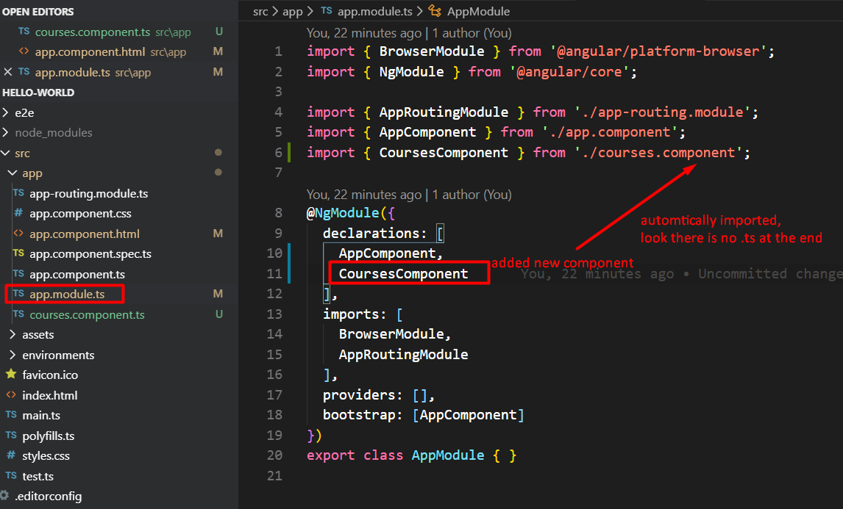

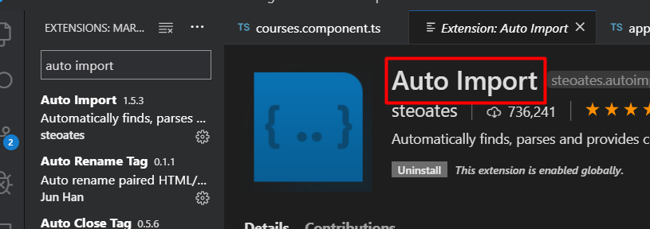

1. **Register the component to app.component.html**

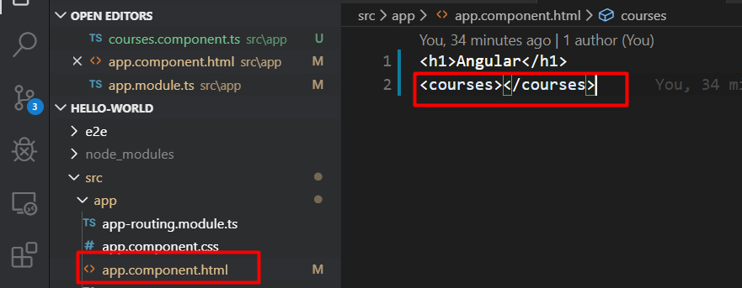

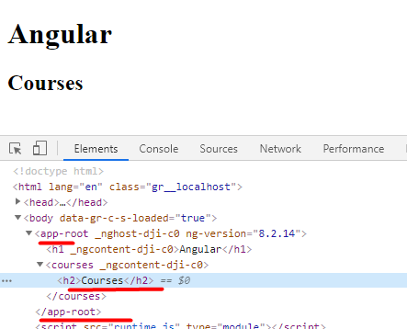

**So where does app-root comes from under the body?**

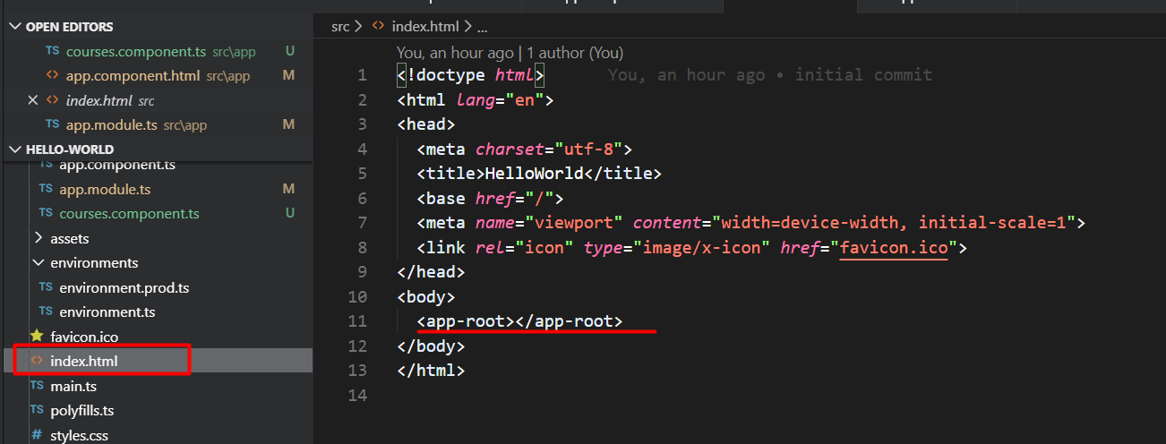

**Comes from index.html under environments.**

**If we have app-root then we should have a component with this app-root selector element.**

**And its component is app.component.ts**

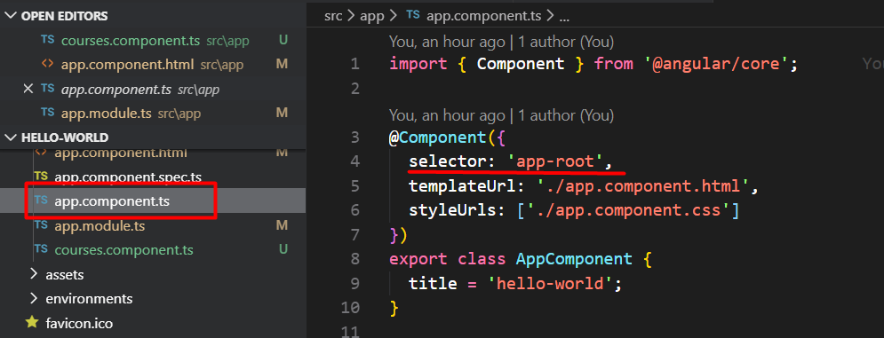

**Its selector is an external URL ./app.component.html**